2.21

Buffett on asset investment:

* Buy assets that yield returns. Be it property or stocks.
* Commodities do not produce income, you are counting on someone else to buy them at a higher price.
* The real test: Buy something that yields return. You would be happy if you have never to be quoted again, you only care about what the asset does for you.
* Retain earning power that’s commensurate with purchasing power. Real assets produce income and the price of real assets reflect the change
* Extract real earnings in terms of business
* USD depreciated 16 times since 1930s.
* Real competitive advantage that lasts
* Productive assets: assets that produce goods or services, not related to currency in which it is denominated

Properties: yield rental income

Stocks: yields dividends.

1. Competitive edge of the company

Buffett has 90 billion in unrealized profits. Buy assets and never sell.

2.23.2018

Sentiment: fidgety

Opening confidence level: 3/10.

Index sold off within the first 5 minutes.

Decision: hold

Reason: sentiment hasn’t recovered yet. Investors scrambling to sell ytd’s gains very quickly.

* 1. weekly recap

China was closed on mon-wed for chinese new year.

Markets rebounded on thurs and fri but overall sentiment feels weak. No all out rebounds, only very weak and tentative advances.

Market sentiments are broken and still need time to fix.

Friday price action was weak, wtd high was reached in the AM and got sold off into the close.

Moutai started to correct before the market and recovered before the market.

On the US side, NQ is the best of the three indices.

Chinese ETFs are at 0.3% premium.

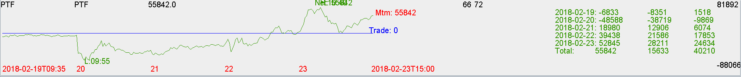

Some thoughts on assets:

Invested in VIX and oil and gold before but these didn’t yield any returns.

Buffett said how do you know you made a good investment? You’d be happy if you never got quoted on it again. This means assets that produce income. Assets are an inflation hedge.

Dabbling with gold shows an immaturity of investment style.